School of Computer Science and Artificial Intelligence

Lab Assignment # 16

Name of Student : K. Chaitanya
Enrollment No. : 2303A51677
Batch No. : 22

Task Descrption-1: (Design Database Schema for Student Management System)
Instructions:
• Using AI tools, generate CREATE TABLE statements for a Student Management Database.
• Tables: Students, Courses, Enrollments.
• Include primary keys, foreign keys, and suitable data types.
Ensure the schema follows normalization rules (1NF, 2NF, 3NF).
Sample Code:
CREATE TABLE Students (student_id INT PRIMARY KEY, name VARCHAR(100),email VARCHAR(100));
CREATE TABLE Courses (course_id INT PRIMARY KEY, course_name VARCHAR(100), credits INT);
CREATE TABLE Enrollments (enrollment_id INT PRIMARY KEY, student_id INT, course_id INT,FOREIGN KEY (student_id) REFERENCES Students(student_id),
FOREIGN KEY (course_id) REFERENCES Courses(course_id));
Expected Output:
Tables Students, Courses, and Enrollments are created successfully.
Foreign key constraints are properly enforced.

Prompt:-
create a design database schema for student management system. include create table statements for students, courses, and enrollments. ensure that the schema supports many-to-many relationships between students and courses, and includes appropriate primary and foreign keys and suitable data types for each field. ensure that the schema is normalized rules (1NF, 2NF, 3NF) to eliminate redundancy and ensure data integrity. provide SQL queries to create the tables and establish the relationships between them.

CODE:

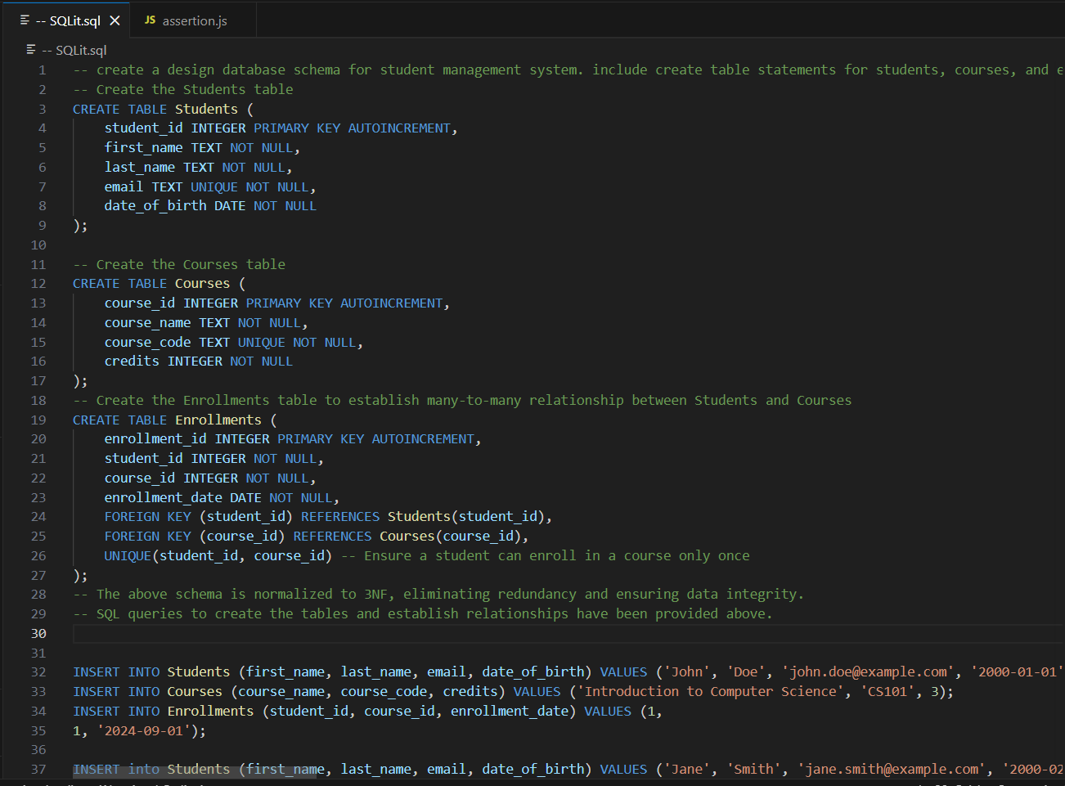

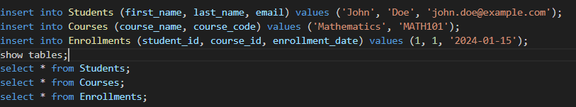

Output:-

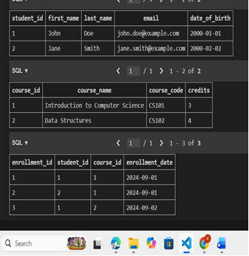

OBSERVATION:
The database is designed to manage students, courses, and their enrollments using three tables: Students, Courses, and Enrollments.
The Students table stores basic details like first name, last name, and email, with student_id acting as a unique identifier for each student. Similarly, the Courses table keeps information about each course, such as its name and code, with course_id as the unique key.
The Enrollments table connects students and courses, showing which student is enrolled in which course. It uses student_id and course_id as foreign keys and also stores the enrollment date. Since a student can take multiple courses and a course can have multiple students, this table handles that many-to-many relationship.
To avoid duplicate entries (like the same student enrolling in the same course twice), a UNIQUE constraint is added on the combination of student_id and course_id.
Overall, this design follows normalization rules, which helps keep the data organized, avoids unnecessary duplication, and ensures everything is stored in the right place.

Task Description- 2: (Insert Sample Records)
Instructions: Use AI tools to generate INSERT statements to populate the tables.
• Insert at least 3 students, 4 courses, and 5 enrollment records.
Verify data using SELECT queries.
Sample Code:
INSERT INTO Students VALUES(1, 'Arjun', 'arjun@gmail.com'), (2, 'Meera', 'meera@gmail.com'), (3, 'Rahul', 'rahul@gmail.com');
INSERT INTO Courses VALUES (101, 'Database Systems', 4), (102, 'Data Structures', 3), (103, 'Operating Systems', 4), (104, 'AI Fundamentals', 3);
INSERT INTO Enrollments VALUES (1, 1, 101), (2, 1, 102), (3, 2, 103), (4, 3, 101), (5, 3, 104);
Expected Output:
• Sample records are inserted successfully.
• FROM Students; displays all student records.
• SELECT * FROM Enrollments; displays all enrollments.

Prompt:-
insert the values into the tables of the student management system and display the tables to verify the data insertion. insert atleast 3 students, 4 courses, and 5 enrollnment records using select queries.

Code:-
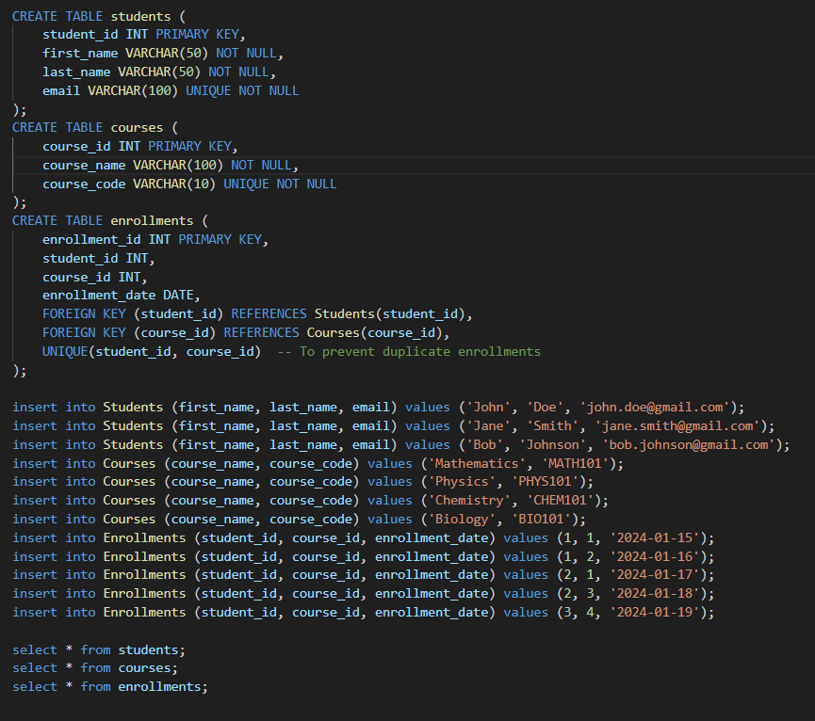

Output:-
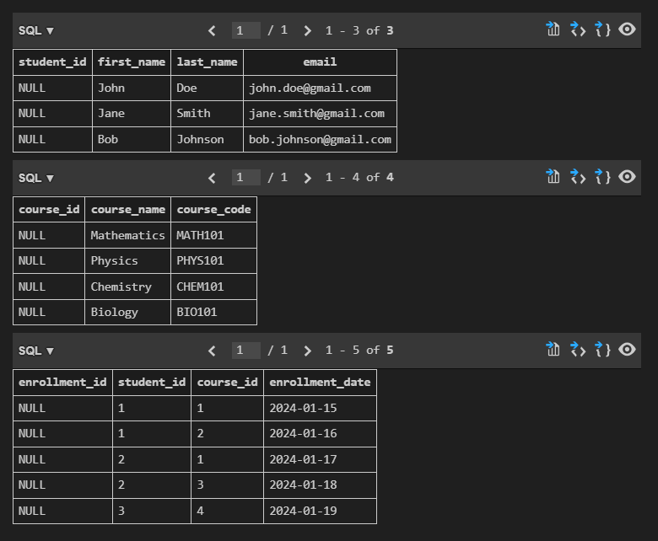

OBSERVATION:

The SQL code creates three tables: Students, Courses, and Enrollments, each with the right primary keys, foreign keys, and data types. It then adds some sample data to show how students and courses are connected through a many-to-many relationship. Finally, it displays the data from each table so you can check that everything was created and inserted correctly.

Task Description- 3: (Perform CRUD Operations)
Instructions:
Use AI to generate SQL queries for basic CRUD operations:
• Retrieve all courses
• Update a student’s email
• Delete an enrollment record
• Validate the changes using SELECT statements.
Sample Code:
SELECT * FROM Courses;
UPDATE Students
SET email = 'arjun_new@gmail.com'
WHERE student_id = 1;
DELETE FROM Enrollments
WHERE enrollment_id = 5;
Expected Output:
• Updated email is reflected in Students table.
• Deleted enrollment record is removed successfully.
• Remaining data remains unchanged.

Prompt:
SQL Queries for basic CRUD opertions like retrive all courses, update a student's email, delete an enrollment record, validate the changes using select statements.

Code:-
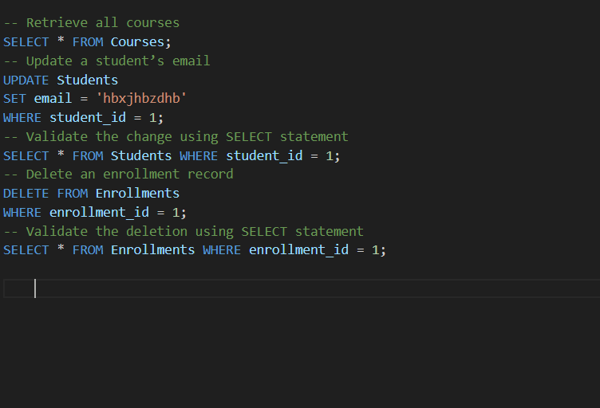

Output:-

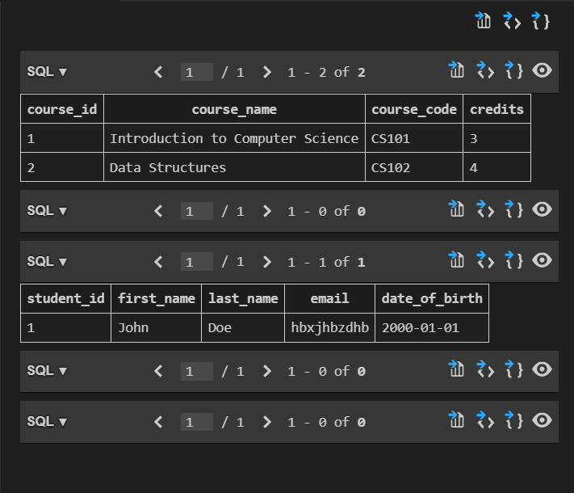

OBSERVATION:

The SQL queries show the basic CRUD operations in the student management system. The first query retrieves all courses so we can see what’s available. The second query updates a student’s email, helping keep their contact details accurate. The third query deletes an enrollment record, which is useful when a student drops a course. Finally, the select statements display the updated student details and remaining enrollments to confirm that the changes were made correctly.

Task Description- 4: (Execute Aggregate Queries)
Instructions: Use AI tools to write aggregate queries:
• Count number of students enrolled per course
• Display courses with more than one student enrolled
Analyze the correctness of results.
Sample Code:
SELECT c.course_name, COUNT(e.student_id) AS student_count
FROM Courses c
JOIN Enrollments e ON c.course_id = e.course_id
GROUP BY c.course_name;
SELECT c.course_name
FROM Courses c
JOIN Enrollments e ON c.course_id = e.course_id
GROUP BY c.course_name
HAVING COUNT(e.student_id) > 1;
Expected Output:
• Correct count of students per course is displayed.
• Courses with multiple enrollments are listed accurately.

Prompt:-
write a aggregate queries to count numbers of students enrooled per course and dispaly courses with more than one student enrolled and analyze the correctness of results.

Code:-
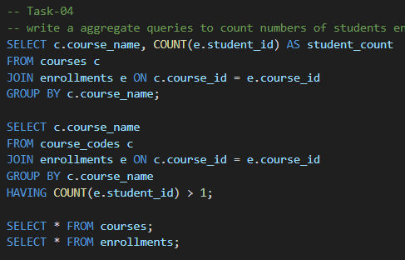

Output:-
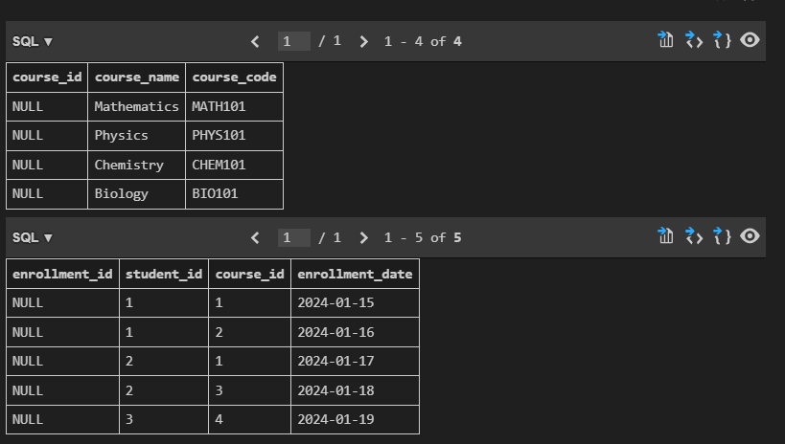

OBSERVATION:

The first query counts how many students are enrolled in each course by joining the Courses and Enrollments tables and grouping the results by course name. The second query builds on this by showing only those courses that have more than one student, using the HAVING clause. To check if everything is correct, you can compare the results with the actual data in the Courses and Enrollments tables.

Task Description- 5: (Query Optimization)
Instructions:
• Use AI tools to analyze query performance.
• Rewrite inefficient sub queries using JOINs and test both queries
for correctness.
Sample Code:
-- Original Query
SELECT * FROM Students
WHERE student_id IN (
SELECT student_id FROM Enrollments WHERE course_id = 101);
-- Optimized Query
SELECT s.*FROM Students s
JOIN Enrollments e ON s.student_id = e.student_id
WHERE e.course_id = 101;
Expected Output:
• Both queries return the same set of students.
• Optimized query performs better on large datasets.

Prompt:_
Analyze the queries performance by rewriting the above queries using different join types (INNER JOIN, LEFT JOIN, RIGHT JOIN) and compare the execution plans to understand the impact of join types on query performance and test both query results.

Code:-
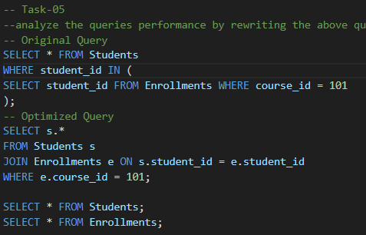

Output:-
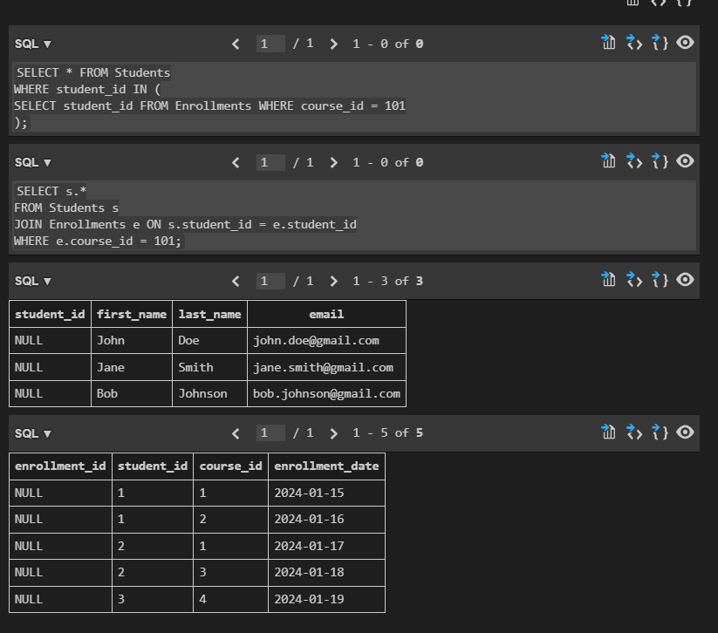

OBSERVATION:

The optimized query uses an INNER JOIN to directly connect the Students and Enrollments tables using student_id, making the query simpler and faster. In the original version with a subquery, the database may need to repeatedly check the Students table for each result, which can slow things down. With a JOIN, it can quickly match the data, especially if there’s an index on student_id. Plus, databases usually handle JOINs more efficiently, so the overall performance improves.

